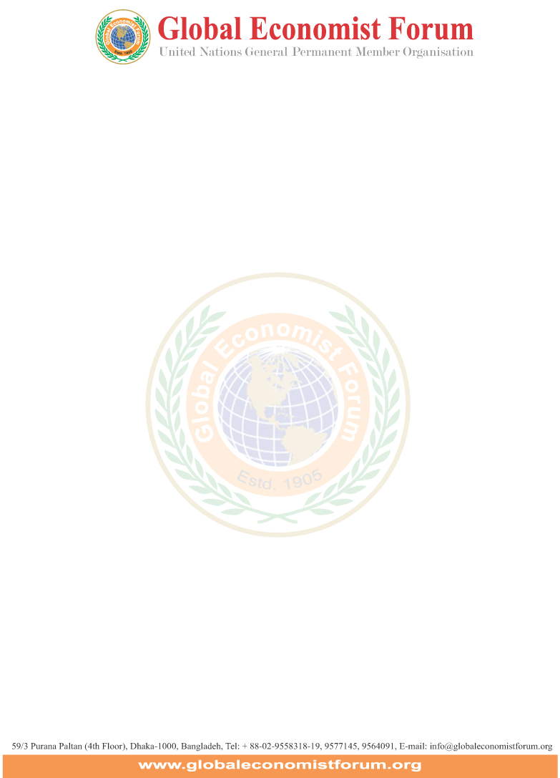

News Release May 04, 2019

Bangladesh needs to implement ‘3-zero’
agenda for becoming developed country

The Global Economist Forum (GEF) demands implementation of ‘3-zero’ agenda in Bangladesh for becoming one of the developed countries by the year 2030. The government should plan budgets targeting to make 0% poverty, 0% unemployment and 0% carbon emission. The GEF board led by its President Dr Enayet Karim approved the recommendations yesterday.

The GEF research found that Bangladesh has made remarkable progress in reducing poverty, supported by sustained economic growth. Based on the international poverty line of $1.90 per person per day, poverty declined from 44.2 percent in 1991 to 13.8 percent in 2016. In parallel, life expectancy, literacy rates and per capita food production have increased significantly. Progress was underpinned by 6 percent plus growth over the decade and reaching to 7.3 percent in 2016-17, according to official estimates. Rapid growth enabled Bangladesh to reach the lower middle-income country status in 2015. In 2018, Bangladesh met the eligibility criteria for graduation from the United Nation’s Least Developed Countries (LDC) list, and is on track to graduate in 2024. Sustained economic growth has increased the demand for energy and transport, and spurred urbanization. Insufficient planning and investment have resulted in increasingly severe infrastructure bottlenecks.

To achieve its growth aspiration of becoming an upper-middle income country by its 50th anniversary in 2021, the country needs urgently to implement structural reforms, expand investments in human capital, increase female labor force participation, and raise productivity through increased global value chain integration. Improving infrastructure as well as the business climate would allow new productive sectors to develop and generate jobs.

The Bangladesh wing of the GEF headed by Dr Mohammad Haider Ali Miah and Dr Mamun-Ur Rashid and Md Ehsan Khasru, President, Secretary General and Advisor respectively unveils the new development plan in presence of its central president Dr Enayet Karim. It is worth mentioning that Haider Ali Miah is also the CEO of Exim Bank while Mamun-Ur Rashid is the CEO of Standard Bank and Md Ehsan Khasru is the CEO of Padma Bank.

Employment
Bangladesh’s unemployment rate increased to 4.38% in Dec 2018, from the previously reported number of 4.37% in Dec 2017. Unemployment rate is updated yearly, available from Dec 1991 to Dec 2018, with an average rate of 3.62%. The data reached an all-time high of 5% in Dec 2009 and a record low of 2.20% in Dec 1991. The data is reported by the Global Economist Forum.

In the latest reports, Bangladesh’s total population reached at 165.55 million people in Jun 2019. The labour force participation rate increased to 56.56% in Dec 2018.

The unemployment rate in Bangladesh is defined as the number of unemployed people as percent of the labor force. The labor force includes the people who are either employed or unemployed, i.e. who don’t have a job but are actively looking for one. The labor force does not include people who are not looking for work, children, and the retired.
The unemployment rate seldom declines below 4-5 percent even during boom times. There are always people who move between different sectors of the economy or between cities. When the economy goes into recession, then unemployment can reach much higher numbers, sometimes even in the double digits.

Unemployment refers to the share of the labor force that is without work but available for and seeking employment.

The GEF recommends a pro-employment budget for the FY 2020 which will help to create more employments for both the educated and uneducated youths. The employment rate could be increased by strengthening private sector credit growth, lowering borrowings by the government.

Carbon emission
Bangladesh is emitting around 200 million metric tons of carbon annually (MtCO2e), with the agriculture industry contributing nearly 40 percent to overall emissions. Bangladesh’s emissions increased 59 percent from 1990 to 2018, with an annual average rate of change of 2 percent.

The Global Economist Forum identifies improving transportation sector energy consumption as a priority since its share of emissions is growing faster than any other sector; although the agriculture industry is the leading emitter of greenhouse gases primarily due to rice production, enteric fermentation, manure and poultry litter management.

The GEF recommends not increasing use of fossil fuel in power plants, rather putting emphasis on solar and air resources for power generation. The budget should formulate guidelines for reducing Carbone emission.

Bangladesh aims to develop from a low income economy to the first stages of a middle income economy by 2021. However, emissions relative to GDP remain well over double the world average and there remains great potential to further reduce carbon intensity. Climate change mitigation targets and plans are outlined in the factsheet.

News sent by-

Arun Sarker
Executive Director
Mob: 01713083876

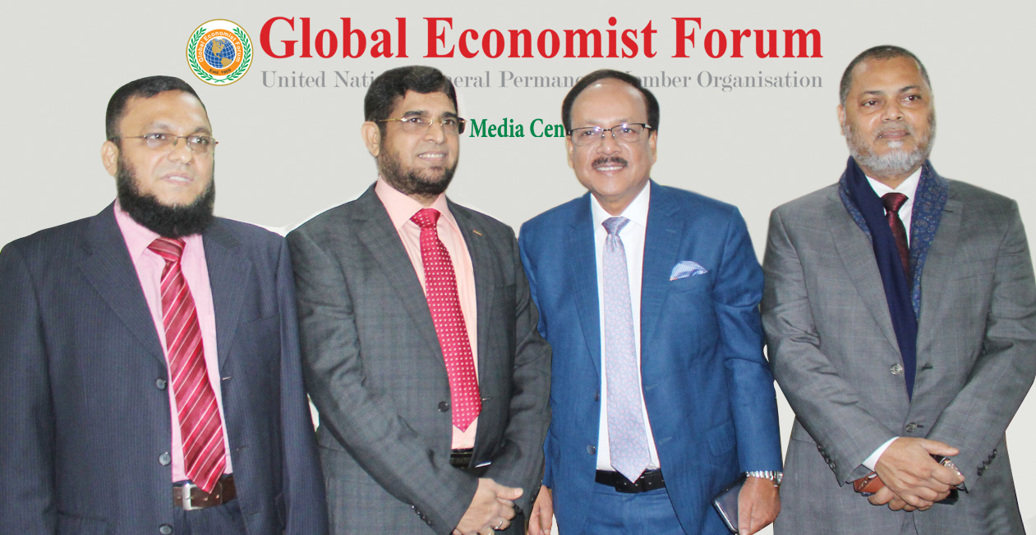

Caption

The Bangladesh wing of the GEF headed by Dr Mohammad Haider Ali Miah and Dr Mamun-Ur Rashid and Md Ehsan Khasru, President, Secretary General and Advisor respectively unveils the new development plan in presence of its central president Dr Enayet Karim.

